Project Tender

Project: *Insurance profiling from social media*

Client: *Retro Rabbit*

Team: *Not Like This*

*Jedd Shneier*

*Daniel Andrew King*

*Joseph Jürgen Muller Potgieter*

*Duncan William Smallwood*

Department of Computer Science, University of Pretoria

Date: 01/05/2016

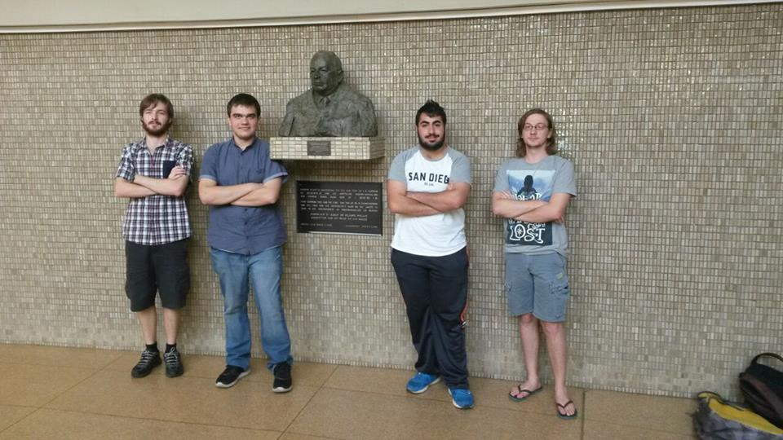

# The Team

Jedd Shneier

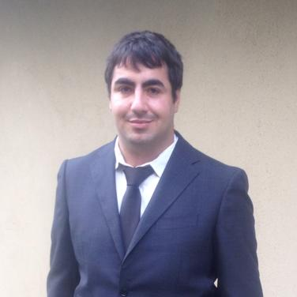

My interests include:

Artificial Intelligence focusing on evolutionary algorithms

Computer networks and Network Security

Logic puzzles and problem solving

History and classic literature

Anime and Animation

Science fiction series

Fantasy Novels

Harmonica

Tennis

My technical skills:

Coding proficiency in:

Java

C++

Python

Delphi

HTML

CSS

Javascript

PHP

SQL

Coding experience in:

Ruby

C#

Scheme

F#

Experience with cloud systems

Proficiency with Latex, GIT, Java EE, JPA and Linux

In the past I have completed modules within the university such as:

* Netcentric computer systems
* Data structures and algorithms
* Concurrent Systems
* Software modelling
* Operating Systems
* Computer Security
* Programming languages
* Computer Networks
* Informatics

And am currently doing:

* Artificial Intelligence
* Software Engineering
* 3rd Year psychology
* Human Computer Interaction

Past experiences:

I have 6 years of programming experience, outside of university I have interned at Lepsta Pty Ltd working on their Black Hole system which was a ”Platform as a service” and so I have experience with cloud service development. I have job shadowed at SensePost, Liberty Life and have developed applications for Johannesburg based company Freight Training. I have experience as a freelance programmer and consultant and as such I am no stranger to fulfilling customer requirements and meeting deadlines.

Non-technical Skills:

I am very good at managing teams and maintaining communication over large projects. I work well under pressure. I am able to stay organized and meet deadlines while at the same time maintaining high quality throughout my work. I learn new topics very quickly. I am a creative and logical problem solver. My greatest skill is my ability to get people from different backgrounds to get together and understand each other. My social networking abilities allow me to get people who may not get along to work constructively and efficiently to produce content that always goes beyond expectation.

Why I want to do this project:

Retro Rabbit is a company I have always been interested in. this project looks exciting and fun. Most of all it looks challenging.

Daniel King



My interests include:

Competitive gaming

Various sports such as tennis, cricket golf and football

Table-top miniature wargames

Artificial intelligence

Game viewing

Science fiction

My technical skills:

Coding in

Java

C++

HTML

CSS

Javascript

WebGL

Some image manipulation (Photoshop)

Video editing

In the past I have completed modules within the university such as:

* Netcentric computer systems
* Data structures and algorithms
* Concurrent Systems
* Operating Systems
* Software modelling
* Calculus and Linear Algebra
* Mathematical Statistics
* Mathematical modelling
* Information Science

And am currently doing:

* Computer Networks
* Computer Graphics
* Software Engineering
* Human Computer Interactions

These are only a portion of the topics I have gone through in my studies however I believe they will allow me to complete the system in a high quality manner.

Past Experience:

Have done web development for company Black Plan

Some non-technical strengths I have are:

* I can focus well on single tasks and make sure they are completed to a quality I deem is acceptable in comparison to the standard
* If I come across aspects which I do not understand or a problem I cannot complete I am able to find and digest information quickly, allowing me to learn how to complete the task in a short amount of time
* I can be critical of members in a group in a constructive way, so that the quality of work stays at an acceptable level
* My biggest strength is my ability to think logically and reason though problems

Why I want to do this project:

The idea of applying insurance profiling techniques to social media is really fascinating to me and I would like to work on this project to expand my own skills.

Joseph Jürgen Muller Potgieter



My interests include:

Reading

Gaming

Nerd culture

Science fiction

Fantasy

Technical skills:

Coding in:

Java

PHP

C++

HTML and Javascript

WebGL

SQL

Artificial Intelligence

In the past I have completed modules within the university such as:

* Netcentric computer systems
* Data structures and algorithms
* Concurrent Systems
* Software modelling
* Operating Systems
* Computer Security
* Programming languages
* Computer Networks
* Informatics

And am currently doing:

* Networking
* Graphics
* Programming Languages
* Information Science

Past experience:

I have previous experience with a professional employer, where I worked in a team. We were tasked with the completion of an Android application and delivered a satisfactory product.

Non-technical skills:

·         Work well in teams

·         Can draft professionally worded documents

·         Experience in public speaking

·         Highly organized

Interest in the project:

It seems as though the project could provide an interesting challenge and provide valuable experience in a professional environment. I have developed a particular interest in Artificial Intelligence and believe that this could prove to be a highly educational endevour.

Duncan William Smallwood



My interests include:

Competitive gaming

Reading

Online discussions

Water Sports

Music

My technical skills:

Coding in

Java

C++

HTML

CSS

Javascript

PHP

SQL

In the past I have completed modules within the university such as:

* Netcentric computer systems
* Data structures and algorithms
* Concurrent Systems
* Operating Systems
* Software modelling
* Calculus and Linear Algebra
* Mathematical Statistics
* Mathematical modelling
* Philosophy

And am currently doing:

* Computer Networks
* Computer Graphics
* Software Engineering
* Human Computer Interactions

Some non-technical strengths I have are:

* Evaluation importance and relevance of new information to a current project.
* Learning new skills.

Why I want to do this project:

I’ve considered this a challenging project and I like to rise up to challenges. I also think this will be valuable learning experience for me and help me realise how to operate in a working environment.

# Project execution

We intend to follow the agile methodology, as was specified in the proposal. We will try to make the weekly meetings, but wish to make it known that, as 3rd year students, our schedules may make this difficult.

We will keep Retro Rabbit informed of our progress, with our weekly meetings. We will be pushing the majority of our work to a Git repository, which we will make public to Retro Rabbit, as another means to track our progress. Should it be deemed necessary, we can communicate through Whatsapp or other mediums.

The most prominent technical challenges will be reading information from Facebook; storing this information in an efficient manner; processing it and producing an accurate output. All within an acceptable time frame for the average user.

The technologies we will use will largely depend on the client's preference. Seeing as they are providing a server, we will discuss what technologies it will use and what they, in their professional experience, would recommend.

At the end of this project the client will have a working system that meets all requirements and goes beyond expectations. We will create a system capable of analysing a user's social media account, in order to generate an accurate risk profile. We intend to optimize the techniques used by the system, when generating a risk profile. We will use encryption, as to avoid the risk of personal information being leaked. The system will be designed in such a way, that it will be easily adapted to use other social media sites or new analysis methods. We intend to create a fully functioning product that will satisfy all the client's needs.